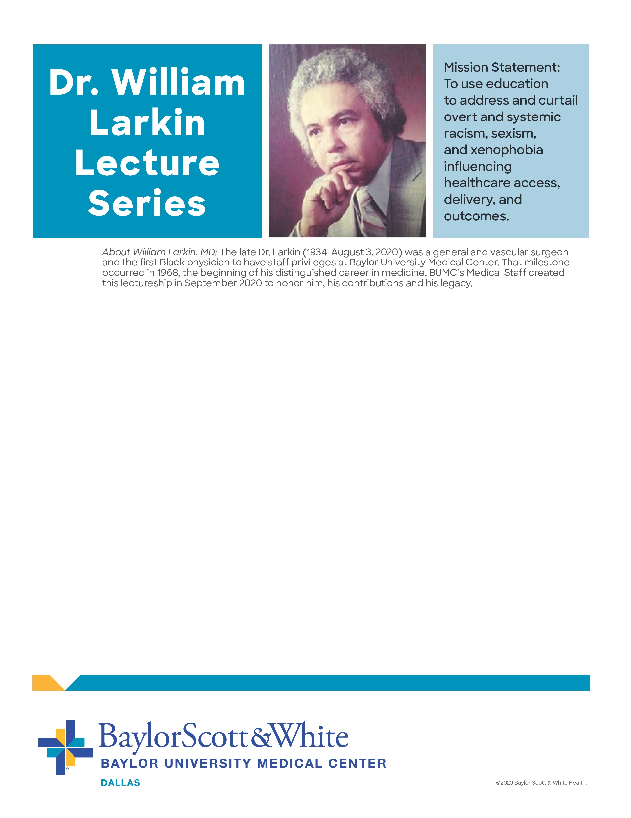

**BUMC Quarterly Medical Staff Meeting**

**Wednesday, Feb. 3 • 7:30 a.m.- 9:00 a.m.**

“Bias and Racism in Medicine: How the Lack of Diversity in Medicine is Killing Our Patients and What to Do About It”

presented by guest lecturer,

Quinn Capers, IV, MD, FACC, FSCAI

Rody P. Cox Professor of Internal Medicine (Cardiology)

Associate Dean of Faculty Diversity

Vice Chair, Diversity, Equity, and Inclusion – Department of Internal Medicine

UTSW School of Medicine

Virtual session hosted by:

**Join by video system:**

Meeting link: dial 1457959006@BSWHealth.webex.com

Meeting ID: enter 145 795 9006

**Join by phone:**

Dial 469-210-7159 and enter access code 145 795 9006