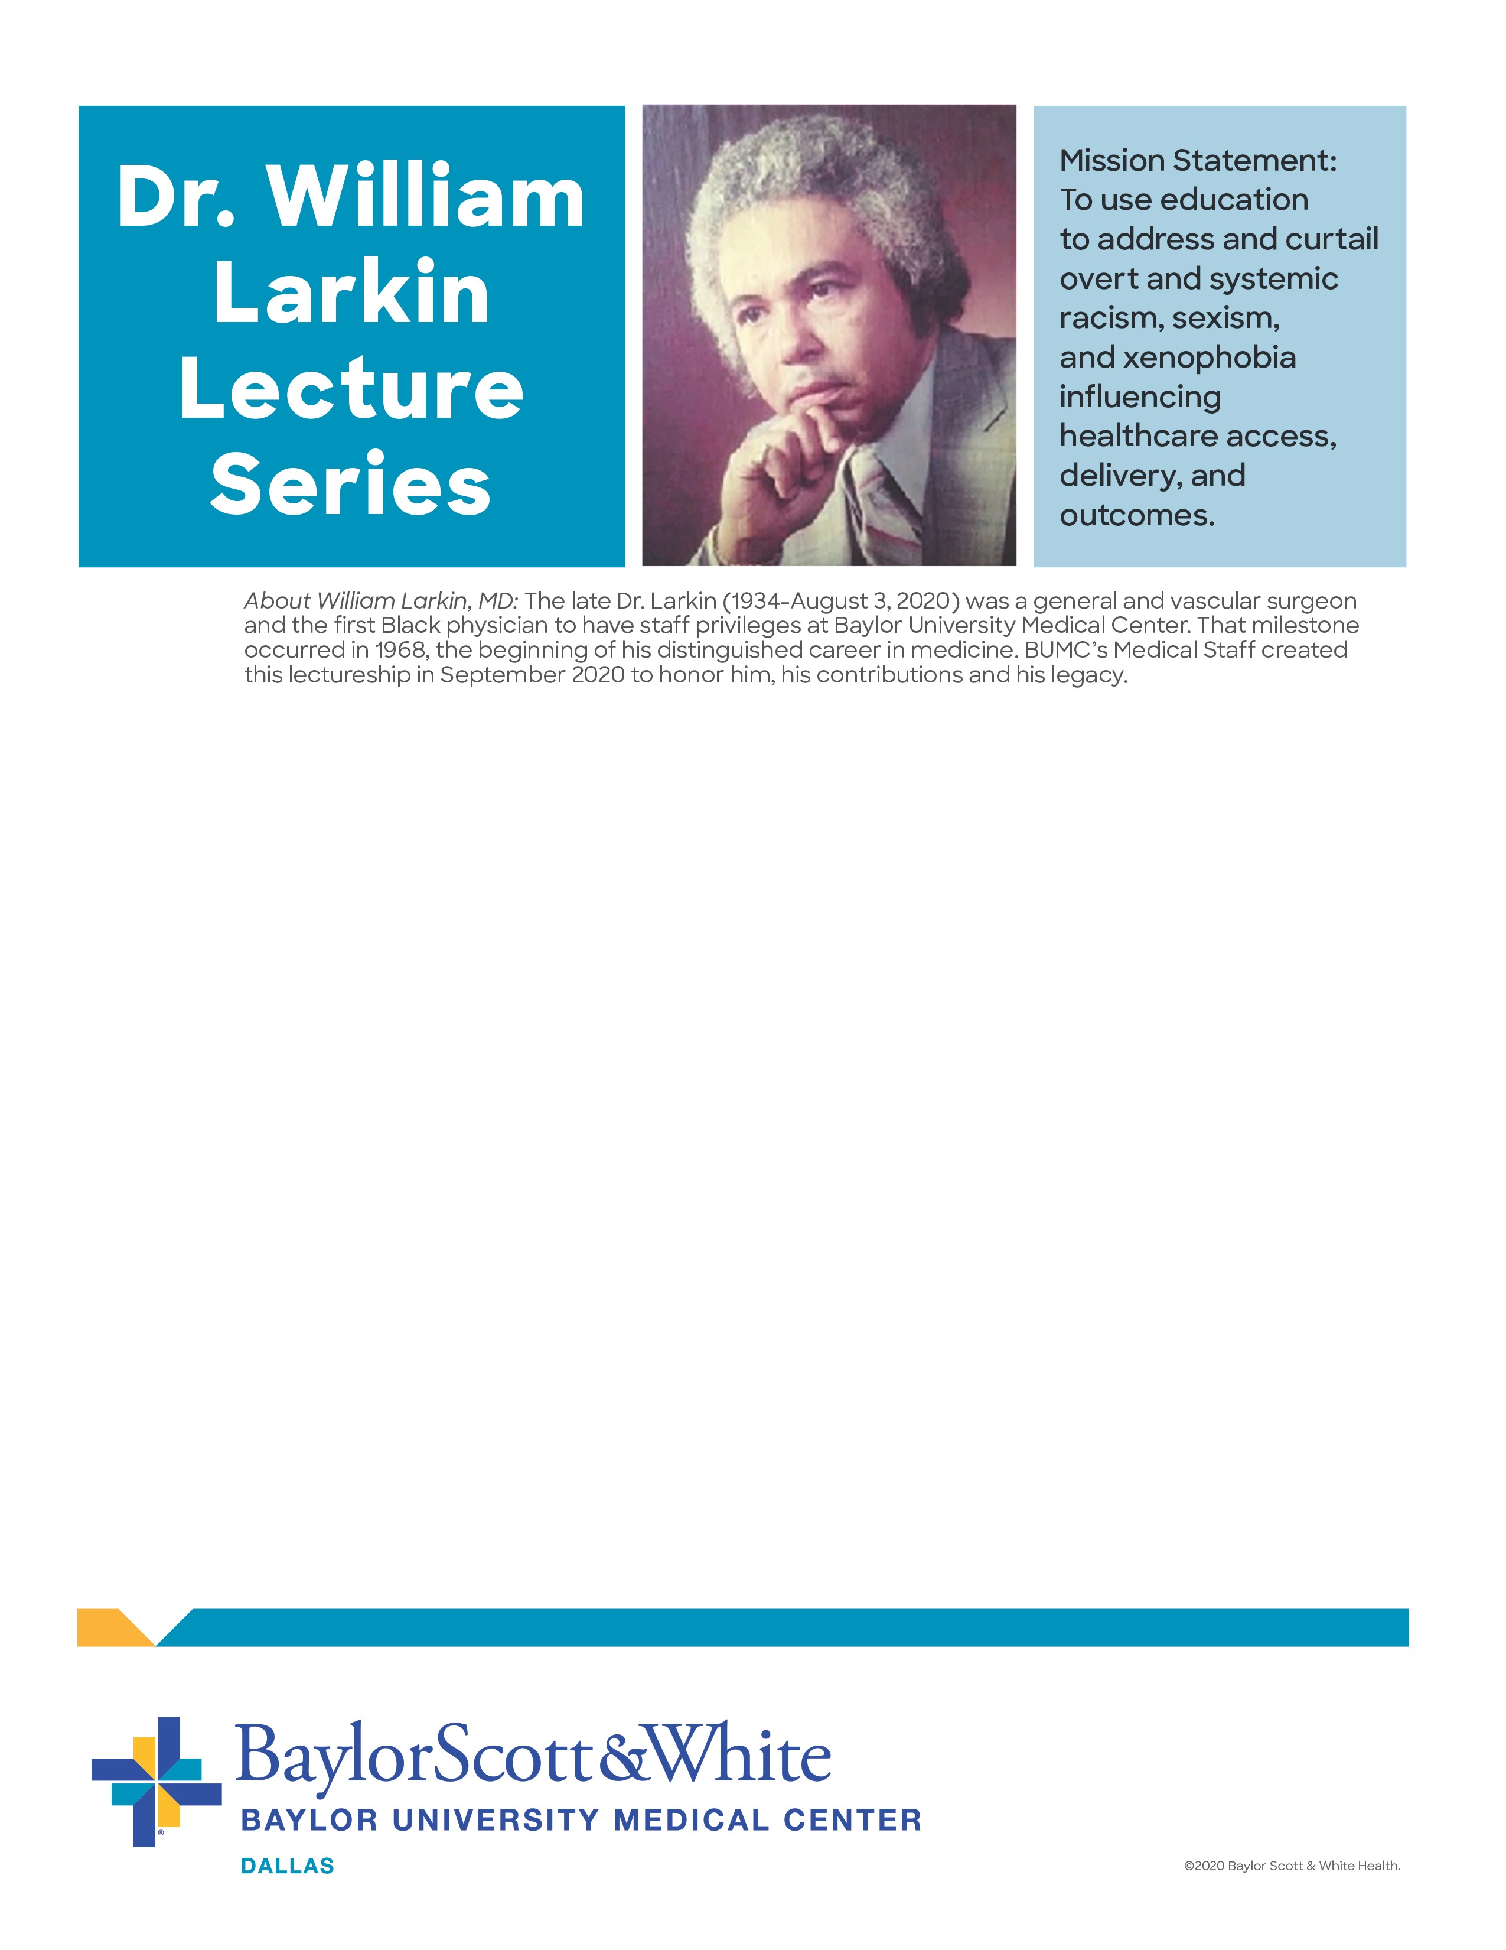

**BUMC University Medical Center**

**Medical Staff Quarterly Meeting**

**Wednesday, Feb. 1st • 7:30 a.m. -9 a.m.**

“Disability as Diversity in Medicine”

presented by guest lecturer,

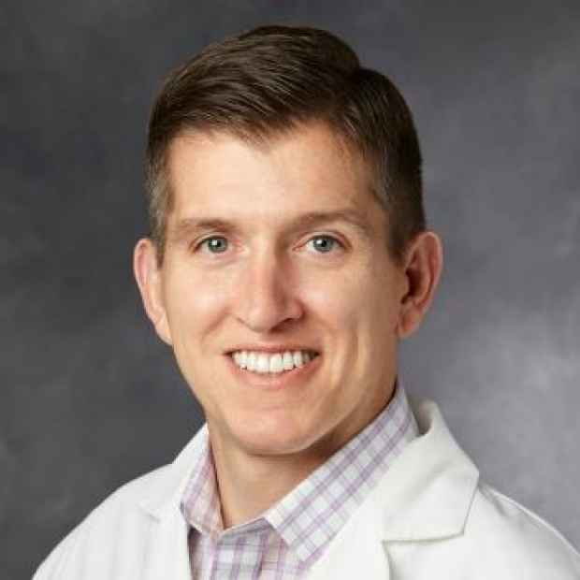

Peter Poullos, MD

Associate Professor of Medicine

Department of Radiology, Gastroenterology, and Hepatology

Stanford Medicine Alliance for Disability Inclusion and Equity (SMADIE)-Founder, Co-Chair

Stanford University Palo Alto, CA

**Join by video system:**

Meeting link: [25940903084@bswhealth.webex.com](mailto:25940903084@bswhealth.webex.com)

Meeting ID: 2594 090 3084

Meeting password: dmKgDHnp946 Join by phone

**Join by phone:**

Dial 469-210-7159 and enter access code 2594 090 3084