***CHANGING LEARNER COMPETENCE FOR BEGINNERS – LET’S START WITH US***

***May 15, 2024***

***Penny Coots, M.Ed. – Director of Continuing Medical Education***

***The A. Webb Roberts Center for Continuing Medical Education of Baylor Scott and White Health - Texas***

**ACCME RESOURCES:**

<https://accme.org/accreditation-rules/accreditation-criteria>

<https://accme.org/accreditation-rules/standards-for-integrity-independence-accredited-ce>

**Standards for Integrity and Independence in Accredited Continuing Education**

**Rules/Policies**

<https://accme.org/accreditation-rules/policies>

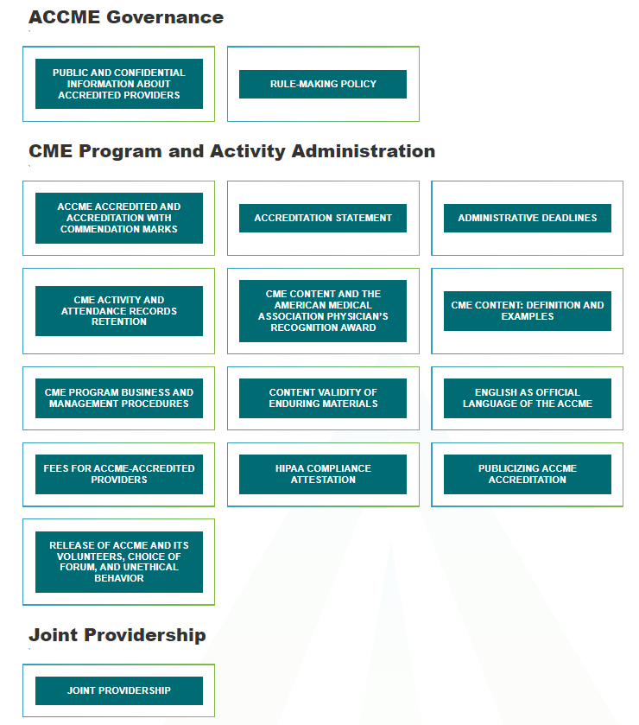

<https://accme.org/publications/standards-for-integrity-and-independence-accredited-continuing-education-toolkit-word>

[DOWNLOAD]

**TEMPLATE:**

**GUIDANCE TEMPLATE:**

<https://accme.org/publications/accmeama-glossary-terms-and-definitions>

**ACCME and AMA Glossary of Terms and Definitions**

**AMA RESOURCES:**

American Medical Association – Follow this link to access this webpage and the associated links held there:

<https://www.ama-assn.org/education/ama-pra-credit-system/ama-pra-credit-system-requirements>

